Case 1: Sales Performance Analysis
Company Background
TechSupply Co. is a regional distributor that sells electronics, office supplies, and office furniture to both retail and business customers. Management wants to better understand sales trends, customer purchasing behavior, and regional performance to improve future sales strategies.
You have been hired as a junior data analyst to explore the sales dataset and provide insights. Your task is to use Excel filtering and sorting tools to answer business questions and provide recommendations.
Dataset: use the techsupply_dataset.xlsx
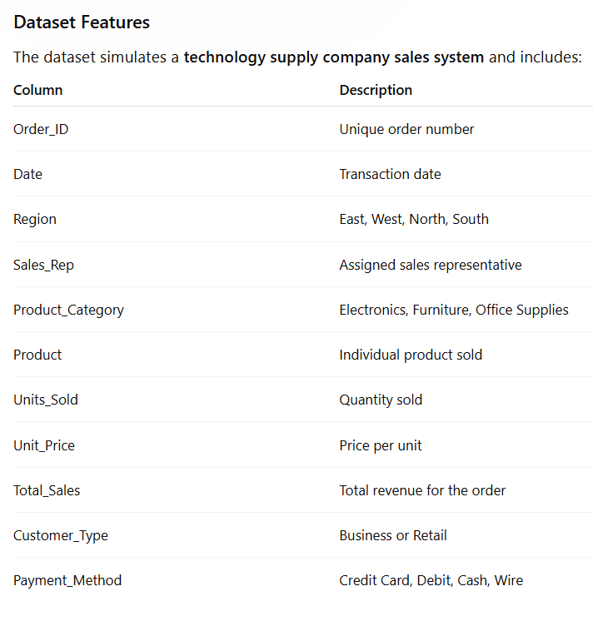

Complete the following 5 tasks.
REGIONAL PERFORMANCE ANALYSIS
Task 1: Use filters to explore sales by region.
- Filter by Region = East
- Sort Total_Sales from Largest to Smallest
Questions:
- What is the largest sale in the East region? Largest sale in the East region is $52,950
- Which product category appears most frequently? Electronics
- Which sales representative appears most often? Brown and Johnson
CUSTOMER BEHAVIOR ANALYSIS
Task 2: Filter by
- Customer_Type = Business
Questions
- Which product category do business customers purchase most often? Office Supplies
- What is the largest business transaction? $63,646.20
- Which sales rep handles the most business orders? Garcia and Brown
PRODUCT PERFORMANCE
Task 3: Use filters to analyze Product_Category.
Analyze each category separately:
- Electronics
- Furniture
- Office Supplies
Questions
- Which category appears to generate the highest total sales? Furniture
- Which specific product appears most frequently? Printer Paper, Notebooks, Filing Cabinets
- Which category tends to have the largest individual transactions? Electronics
PAYMENT PATTERN ANALYSIS
Task 4: Filter by Payment_Method
Analyze:
- Credit Card
- Debit
- Cash
- Wire
Questions
- Which payment method is used most frequently? Credit Card
- Do business customers prefer a specific payment type? They prefer Debit Card
- Which payment type is associated with larger purchases? Wire
TOP SALES REPRESENTATIVES
Task 5: Sort by:
- Sales_Rep
- Total_Sales(Largset > Smallest)
Questions
- Which sales rep appears to handle high-value transactions? Singh
- Which rep appears most frequently in the dataset? Brown
- Which region do they appear to sell in most often? West
ANALYST RECOMMENDATION
Imagine you are presenting your findings to management.
Answer the following:
- Which region appears to be the strongest market? The east region
- Which product category should the company promote more? Office Supplies
- Are business customers or retail customers more valuable? Business
- What two recommendations would you give the sales manager?
- Assign the top representatives to regions that are doing poorly in comparison to the top regions.
- For Office Supplies: Adjust pricing or market more heavily to your customer types (other than business where it’s the top category)

Bonus
Build
- Bar Chart – Sales by Product Category
- Pie Chart – Customer Type Distribution
- Column Chart – Sales by Region
What story does the data tell?
According to the data, the top performing region is East with $582,615 in sales.
The furniture category performs the highest in sales as far as totals, but the most frequent ordered products are in the office supplies category. This means that the office supplies category has potential for growth.
Even though business customers order more frequently and make up more than half of the clientele, retail customers generate a slightly higher revenue. This means that we can explore some strategies to have more orders with our retail customers.

